**Theme: A Year of Interacting with Nature**

* ***Submitted Award 18, Newsletter and Yearbook Awards, also Busy Bee Award and Perennial Bloom Award, earning our club***
* 7 District 1 Awards
* 7 NCAGC Awards
* Busy Bee – Deborah
* Perennial Bloom – 2015 – Arminta, 2016 –Linda
* ***District 1 Spring Meeting at the Arboretum***
* In support of District 1, our club members provided an awesome smorgasbord of food and the most beautiful flower arrangement for the center piece to represent our club at the spring meeting loved by all…lots of compliments
* Spring Meeting - Deborah Determan received the Busy Bee Award for taking on the newsletter and yearbook project.
* ***Programs - 6***
* Getting Your Garden Ready for Winter, Our Local Water Shed ,Aging Backwards, Trees and Shrubs, Hives in the City, Becoming a Master Gardener
* ***Design Events –5***
* St. Thomas Church Fall Festival, Gift Box Decoration Contest, Floral Design using Succulents, District 1 Flower Show, Labeled piece of Horticulture
* ***Membership***
* 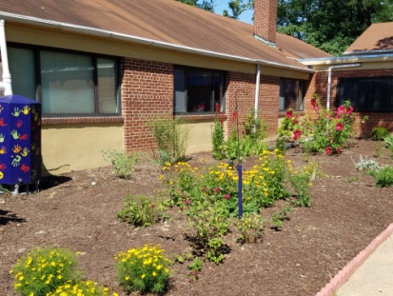Started with 22, ended with 20 (MaryBeth went to Member Emeritus status and Jackie George resigned by letter)
* ***Activities***
* ***Holloway Estates garden maintenance***
* Installed an exquisite Marian Lee Azalea
* Maintenance trip planned for fall
* ***Lutheran Church landscape and garden maintenance***
* 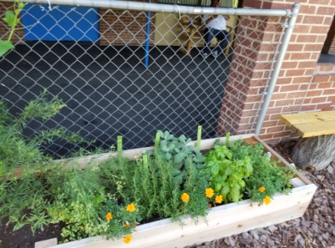Maintenance performed and garden will need to be dismantled in fall
* ***Surratts-Clinton Library***
  + Supported Spring gardening programs with plants by Esther and Linda
* ***Dupont Park Adventist Elementary School (both pics) → → →***
* Members provided assistance with putting in an edible and wildlife garden and painting plant labels and making stepping stones. Club members donated some plants for the project.
* ***Flower Show***
* 5 members participated
* 2 members won awards
  + - Horticulture - Julie had two 1st Place finishes and Linda had a 2nd Place finish
    - Class 4 Design – Julie took 1st Place with her “Dining Al Fresco” Tray and Linda had a 2nd Place finish with her tray
    - Class 2 – Julie took 3rd Place with a design called “Hot Hot Hot”
    - Novice Ribbon – Julie
* ***Field Trips***
* Hidden Acres Nursery, 8 members attended
* 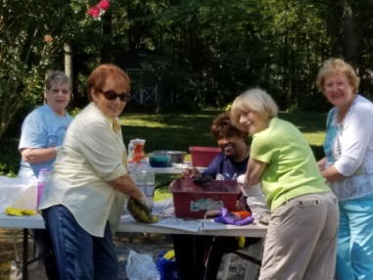Cat’s Meow Daylily Gardens, 8 members attended
* 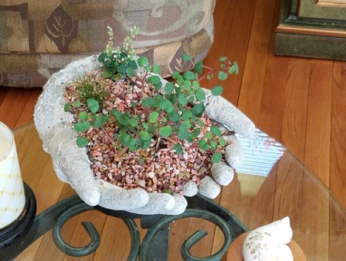***Summer craft workshops planned***
* Concrete ‘hands’ planter,

7 members attended

* Bird bath/feeder made from leaf imprints…September 22nd
* ***Annual potluck picnic…hosted by Lorraine Leonard and held Julie Harrison’s house***
* ***Annual Christmas Potluck/Gift Exchange***
* Lucille Gwynn inducted as new member of the garden club
* 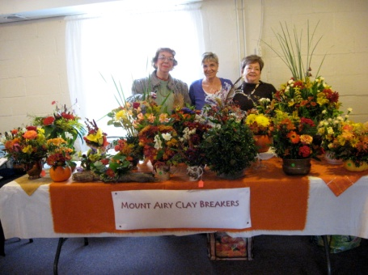***Fundraisers***
* ***Plant Sale***
* Sign repainted
* Raising $ 415. + $ 91. = $ 506.00
* ***Fall Fundraiser***
* Raising $ 340.00
* ***White Elephant Sales***
  + Raising $ 196.00
* ***Club signed up to provide a volunteer one day a month for the Arbor House***
* Club voted and selected the last Thursday of each month to provide a volunteer to assist at the Arbor House. The list is maintained in the Yearbook.

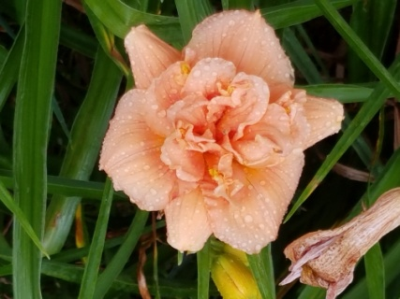

* ***Ending balance $ 2197.79***

*Submitted by Lenay O’Quinn, President*

Cat’s Meow Daylily